How to Write a Memo
A memo is intended to inform a group of people about a specific issue, such as an event, policy, or resource, and encourages them to take action. The word “memorandum” means something that should be remembered or kept in mind. ^{[1]} Here’s a guide to writing readable, effective memos.

Writing a Memo
- 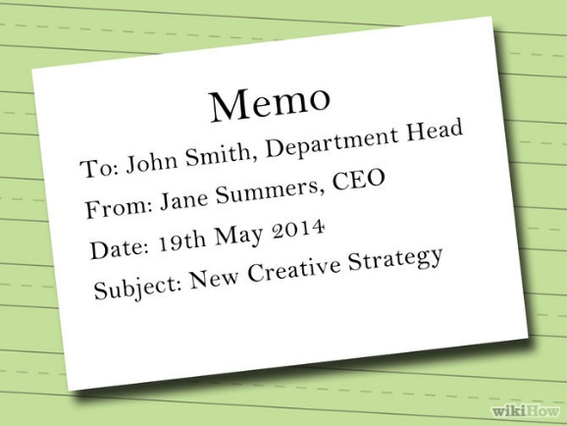
1. Write the heading segment. Specify who the memo is for and who sent it. The heading segment should also include the complete and exact date the memo was written, and the subject matter (what the memo is about). A sample heading would look like: To: Name and job title of the recipient From: Your name and job title Date: Complete date when the memo was written Subject: (or RE:) What the memo is about (highlighted in some way)
  - Always address readers by their correct name; do not use nicknames.
  - When constructing the heading, be sure to double space between sections and align the text.

- 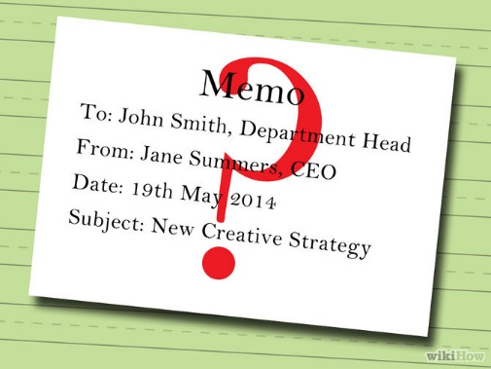
2.Consider who the audience should be. In order to get people to read and respond to the memo, it’s important to tailor the tone, length, and level of formality of the memo to the audience who will be reading it. Doing this effectively requires that you have a good idea of who the memo is intended for.
  - Think about your audience’s priorities and concerns are, and try to imagine why the information you are presenting would be important to them.
  - Try to anticipate any questions your readers might have. Brainstorm some content for the memo, such as examples, evidence, or other information that will persuade them.
  - Considering the audience also allows you to be sensitive to including any information or sentiments that are inappropriate for your readers.
3.Introduce the problem or issue to your readers in the opening segment. Briefly give them the context behind the action you wish them to take. This is somewhat like a thesis statement, which introduces the topic and states why it matters.
  - Include only as much information as is needed, while still being convincing that a real problem exists.
  - As a general guideline, the opening should take up about ¼ of the total length of the memo.^{[2]}
- 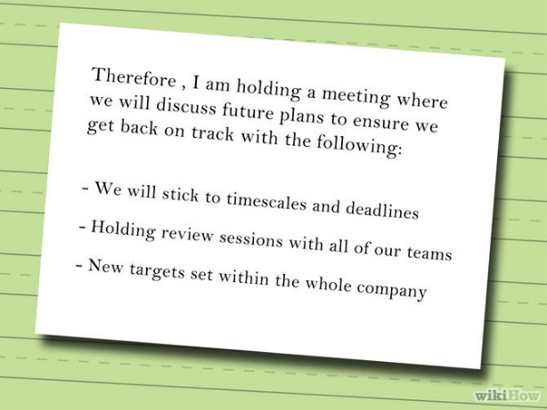
4. Suggest ways to address the issue in the summary segment. What you are summarizing here are the key actions you would like your readers to take.
  - This can also include some evidence to back up your recommendations.
  - In a very short memo, it might not be necessary to include a separate summary segment. Instead, this can be integrated into the next segment, the “discussion segment”. ^{[3]}.
5. Support your course of action in the discussion segment. Be persuasive. State how the readers will benefit from taking the action you recommend, or be disadvantaged through lack of action.
  - Give evidence and logical reasons for the solutions you propose. Feel free to include graphics, lists, or charts, especially in longer memos. Just be sure they are truly relevant and persuasive.^{[4]}
  - Start with the most important information, then move to specific or supporting facts.
  - The general guideline for length is that the summary and discussion segments combined should comprise about ½ of the memo.
- 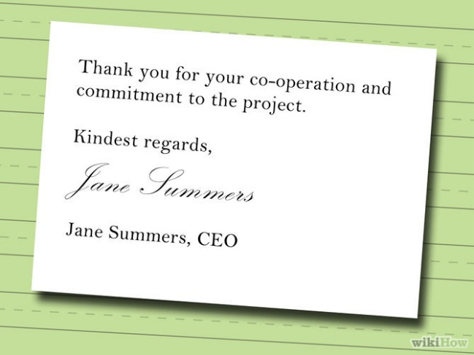
6. Close the memo with a friendly ending that restates what actions you want the reader to take. You might want to include a statement like, "I will be glad to discuss these recommendations with you later on and follow through on any decisions you make."
  - Give the reader a sense of solidarity and optimism if possible.
  - Emphasize a particular next step that they can take.
  - This should generally take about ⅛ of the total length of the memo.
7. Review and edit your memo to make sure that it is clear, concise, persuasive, and free of errors. Check that you are consistent in the type of language that you use, and eliminate unnecessary scholarly words or technical jargon.
  - Review for spelling, grammar, and content errors. Pay particular attention to names, dates, or numbers.
  - Check that it is not excessively long, and cut out any extraneous material.

